Data Science Project Protocol

Machine Learning Model for prediction of algal growth, using maritime observatory

Author(s): Dalit Roth Rosenberg

Introduction
The marine microalgae are primary producers responsible for almost 50% of the Earth's oxygen and form the foundation of the marine food web. Understanding microalgae growth is crucial for comprehending global cycles and the interactions among marine organisms. However, other aspects, such as algal blooms, are also under intense investigation. Harmful algal blooms (HABs) are identified by the rapid accumulation and increased concentration of the microalgal population. These blooms, usually resulting from an excess of nutrients, significantly impact the environment. They can lead to a dramatic depletion of oxygen, reduced light penetration, and the release of harmful toxins affecting various trophic levels.

HABs pose a significant threat to coastal areas and are often associated with large-scale marine mortality events. Consequently, extensive studies on HABs are being conducted by the National Centers for Coastal Ocean Science. Scientists utilize various technologies to predict the probable formation of HABs, their locations, and their potential impacts.

Although the East Mediterranean Levant is highly oligotrophic (low in nutrients) and experiences fewer massive blooms, rapid algal growth does occur. Hence, understanding the biotic and abiotic factors triggering this extreme growth becomes valuable.

Our objective is to develop a model capable of predicting microalgae growth in the marine environment 24 hours in advance. Additionally, we aim for this model to explicitly explain essential factors (geophysical and environmental) influencing algal growth leading to blooming.

What influences the outcome? Algal blooms are known to be influenced by high nutrient availability combined with optimal temperature and light conditions. Increased nutrient loading from human activities is linked to more severe and frequent blooming. HABs also follow a predictable seasonal pattern due to coastal upwelling, a natural outcome of certain ocean currents. Phytoplankton growth varies seasonally, with blooms peaking in spring and summer in high latitudes like the East Mediterranean Sea, corresponding to increased sunlight and reduced water turbulence caused by winter storms.
Blooming may also be specific to certain genera and dominant during different times of the year. Winds play a pivotal role in phytoplankton distribution by driving currents that bring nutrient-rich deep water to the surface.

A proxy for algal levels is Chlorophyll A (chlA). ChlA, the primary pigment in all photosynthetic organisms, can be routinely monitored using sensors or remote sensing (satellite). These measurements indirectly indicate chlA concentration (ug/L). For our model, we'll utilize chlA data obtained by the Texas A&M - Haifa Eastern Mediterranean Marine Observatory (THEMO1) sensor, positioned at the edge of the continental shelf at approximately 125m depth (33.04°N, 034.95°E). THEMO1 generates data samples every 30 minutes from 32 to 40 sensors simultaneously.

Environmental models typically rely on signals like light, temperature, and nutrients to predict algal bloom seasonality on a monthly or seasonal scale. However, THEMO1 provides high-resolution meteorological and geophysical data (e.g., temperature, humidity, turbidity, salinity, wave intensity, wind speed). Leveraging this data could lead to more precise predictions of algal blooms within a shorter time frame, potentially offering novel insights.
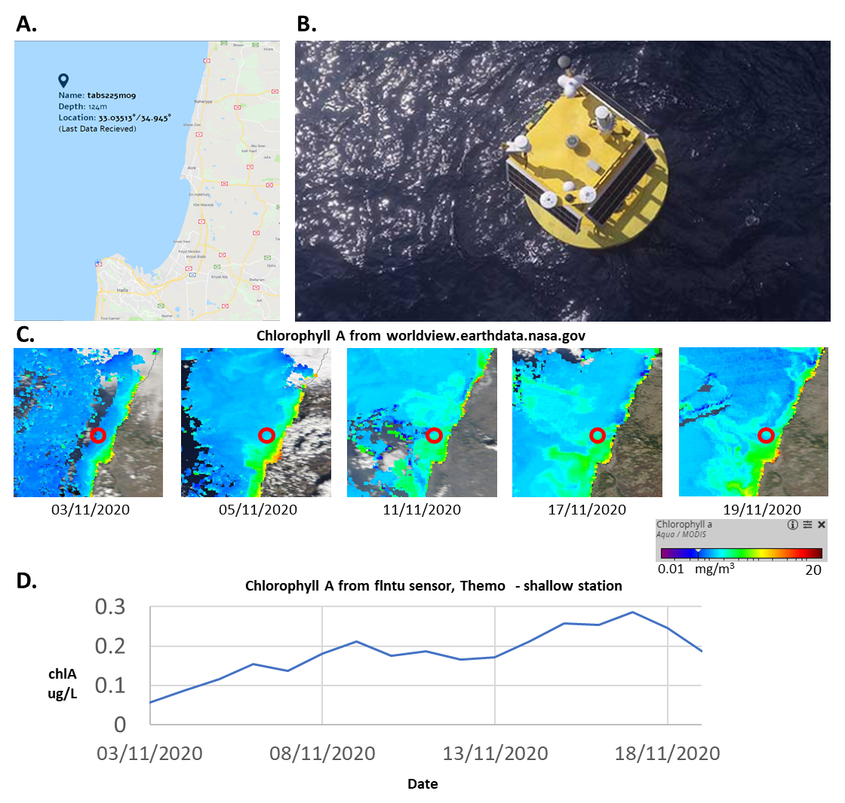
Figure 1. THEMO observatory and algal growth within time. A. show the location of the THEMO (B). C. shows the change in algal growth (satellite view) for two weeks. D. show the change in algal concentrations, during the same days, which are similar to satellite measurements.

Methodology (Project design)

Data
We have collected data from sensors that are located on THEMO1. Table 1. describes the information regarding each of the sensors (Data retrieval protocol and informative description of the parameters are presented at the appendix). To build the model, I have collected all the measurements that could be retrieved from each of the sensor, these measurements are presented in the appendix retrieval table :

External and internal data sources
To form the core of our model, we've designated THEMO1 sensors as the primary or internal data source. These sensor data will be integrated as a Flat File, organized based on rounded time intervals. Additionally, there will be supplementary external data sources incorporated independently.

The outcome feature chl_pred
To train the model to predict algal growth 24 hours in advance, we have selected chlorophyll_concentration as the target feature. This feature will be used from 48 points ahead in time (representing the next 24 hours), and 48 new rows have been added to the dataset to facilitate this prediction.

Table 1. THEMO1 sensors information.

External data sources that may enrich our data

Recognizing the significance of solar time in influencing the growth of photosynthetic organisms, we have gathered the following crucial values for each date in our time series: Sunrise Time (LST), Sunset Time (LST), Sunlight Duration (in minutes), True Solar Time (in minutes), and Sun Declination (in degrees). These values were computed using the "NOAA_Solar_Calculations_year" calculator file, available on the NOAA website. Retrieving these values involved inputting THEMO1's coordinates, the relevant time zone, and the specific date. This date-and-location-specific solar information can serve as a valuable tool to represent cyclic and seasonal data trends associated with both date and location on Earth (refer to the appendix).

This supplementary solar data adds an important temporal dimension to our dataset, allowing us to incorporate precise solar-related variations relevant to the date and geographical coordinates of THEMO1. Such detailed solar information can significantly enrich our understanding of the environmental factors affecting algal growth, especially concerning the cyclic and seasonal aspects related to solar influence.

Preparation of the data:

Data source | Feature name | Treatment
flntu | Chl_pred, chlorophyll_concentration, | Values <0 changed to 0 (technical problem0 | python
All tables | D_stamp | Converted to date | SQL
All tables | T_stamp | time | SQL
depth_xxx(depth) | Above threshold limits | Change all the 46.34 and 46.340 values into null. | python

Dataset time frames periods
Our dataset comprises a time series of measurements collected at a frequency of every 30 minutes, resulting in 48 samples per day. The dataset encompasses approximately 19,000 samples in total. This high-frequency sampling rate, capturing data every half-hour, allows for a detailed and granular understanding of the environmental parameters and their variations over time. With a substantial volume of 19,000 samples, our dataset offers a comprehensive representation of the dynamics and trends in the measured variables, providing ample information for robust analysis and modeling.

Variables that may affect the outcome

From THEMO sensors, there are some variables that might affect algal growth:
Direct effect | Indirect effect
Surface currents | Wind magnitude
Salinity | Humidity
Water temperature | conductivity
Turbidity | Barometric pressure
Water currents | Air temperature
 | waves

A diagram of those connection is presented in figure 2.

There are some variables that affect the growth directly and indirectly, one of them is water temperature which affect the algal physiologically (optimal growth range) and the environment physically (affect water stratification therefor density).

Figure 2. Dependencies datasets measured in THEMO (Diamant R. at al, 2020)

There are also some relationships between data measurements. For example, some anomalies in temperature shown to correlate at different depths.
Figure 3. Temperature data at three water depth measured in THEMO (Diamant R. at al, 2020)

Explanatory Data analysis

Descriptive Statistics and Data Summary:
We extract descriptive statistics—mean, median, minimum, maximum, and percentiles. This allowed us to identify features exhibiting suspicious characteristics, such as negative values, extreme highs or lows, and zeros.

Visualization and Feature Analysis:
For visualization and detailed analysis of features, we leveraged Sweetviz. Visual assessment of feature distributions was conducted, employing tools like sns.distplot to visualize distributions before and after transforming negative values to zeros. Additionally, boxplots were utilized to identify outliers within the features.

Handling Missing Values:
Identification of missing values was performed using methods like isnull().sum() and Sweetviz, focusing on features with a lower count and more than 90% missing values. Heatmaps and correlation matrices were employed to understand missing value patterns and relationships between features. This helped determine if the missing values were random or had a structured pattern.

Temporal Patterns and Feature Relationships:
To comprehend feature patterns over time, consistency, and gaps, we plotted feature representations against the index. This analysis revealed gaps and correlations within the data structure.

Pairwise Relationships and Correlations:
Seaborn's pairplot function was used to plot pairwise relationships between features. Spearman correlation (suitable for non-normally distributed data) and sns.heatmap aided in identifying highly correlated features. Features exhibiting strong correlations were earmarked for further examination and potential handling to address multicollinearity issues.

Data enrichment

Pre-Retrieval Enrichment:
Treatment Before Retrieval: This stage involved enriching variables using various methods and applications before the data was integrated into the Flat File.

Post-Retrieval Enrichment:
Treatment After Retrieval: Following the retrieval and integration of data into the Flat File, additional enrichments and modifications were applied to specific variables using diverse techniques and applications.

Description of Enriched Features Table:
A detailed table outlining the description of each enriched feature. This table delineates the treatments, enhancements, or modifications applied to each variable both before and after retrieval. It serves as a comprehensive reference, illustrating the specific transformations made to individual features at different stages of the data enrichment process.

Feature name | Data source | Description/remark | Treatment | platform
Before
g_x(depth) | temperature | Depths temperature from S9 sensor | Transpose of temperature values to columns according to depths | SQL
depth_x(depth) | speed[m/s] | Depths doppler reads from ADCP sensor | Transpose of doppler values to columns according to depths | SQL
T_round1 | All the sensors | Retrieved from t_stamp | Round the time to the closest 30 min (0 or 30) to join tables. | SQL
After
'minute',  'hour' | T_round1 | Transform a time feature into numeric | divide the date into day and month | python
'T_round2' | T_round1 | Transform a time feature into numeric but split the day into two halves | create another hour column (12 h) and am/pm column | python
'am/pm' | T_round2 |  | create am/pm column | python
'year',  'month',  'day' | d_stamp | Transform a date feature into numeric | divide the date into day and month | python
"avg_g", "std_g" | g_x | High Stdv and var of temp in water column indicate mixing or mix layer which related to upwelling of nutrient/season/algae growth | calculated average and stdev out of temperature at different depths. | python
Sun_Declin_deg  Sunrise_Time_LST  Sunset_Time_LST  True_Solar_Time _min  Sunlight_Duration_minutes | "NOAA_Solar_Calculations_year.xls" |  | Added coordinates, time zone, and dates.  The values of those features were added manually to df_merge1_row_sun2.csv | python
'L/D' | 'T_round1  'Sunrise_Time_LST'  'Sunset_Time_LST' | Add day/light hours, as 0/1 calculated from sunlight hours. | 'T_round1 between  'Sunrise_Time_LST'  'Sunset_Time_LST' than 1. | python
'seasonality2'  'seasonality12'  'seasonality24'  'seasonality48'  trend2  trend12  trend24  trend48 | 'chlorophyll_concentration' | Find the seasonality and trend of the 'chlorophyll_concentration' | decompose the chlorophyl variable for period=2,12, 24,48 | python
'chl_change' | 'chlorophyll_concentration' | Show the trend of algae change | from 'chlorophyll_concentration'- calculate the change level (x-(x-1)) in the excel file | excel
'chl_mov_avg' | 'chlorophyll_concentration' | Show the trend of algae growth | from 'chlorophyll_concentration'- calculate average within a day(48 points) | excel

Outliers treatment

Decision Criteria:
To determine the treatment of outliers, I conducted two tests:

Kolmogorov-Smirnov Test: Compared feature distributions against 'y' before and after outlier removal (transformed to null values). Outliers were defined as 0 and 1 in one dataset and as null and 1 in the other.
Fisher Z-transformation: Evaluated changes in correlation coefficients between each feature and 'y' before and after outlier removal (transformed to null).
Decision Making:
Outliers were removed if:

- One test showed significance (<0.05), or if none did.
- Outliers that both tests identified as significant were retained.

missing values

Handling Missing Rows:
- Rows with >70% missing values were removed. This accounted for 0.2% of total rows (51 out of 19,334).
Handling Missing Columns:
- Columns with >80% missing values were removed: 'depth_113', 'depth_111', 'depth_109', 'depth_107', 'depth_105'.
- For columns with 40-80% or <40% missing values:
  - Checked for randomness using the Kolmogorov-Smirnov test to discern Missing At Random (MAR) or Missing Not At Random (MNAR).
  - For MAR (p-value > 0.05), imputation was applied.
  - For MNAR (p-value ≤ 0.05), transformation into a categorical variable was performed.

Categorical Transformation:
Implemented a quantile-based categorical transformation to reflect variable distribution characteristics, dividing them into categories. Detailed coding specifics are available in the Python notebook.

Conclusion:
The outlier treatment involved statistical tests to determine significance before deciding whether to remove outliers. Similarly, missing values underwent a systematic process, removing rows with substantial missing data and categorizing columns based on randomness and percentage of missing values. The categorical transformation adopted a quantile-based approach, aligning with the distribution characteristics of the variables.

Models
Data Splitting and Balancing:
Random Division:
The dataset was randomly divided into training, development (dev), and test sets. Maintaining a balance in proportions aligned with the data size (19,334 rows) was pivotal. The split was achieved as follows:

- Initially, the data was split into train:test in a 70:30 ratio, aiming to retain around 10,000 rows for training.
- Subsequently, the training set was further divided into train:dev in a proportion of 56:14:30 for train:dev:test.

Balance Verification:
The balance of the splits was confirmed by comparing Mean Absolute Error (MAE) metrics of fitted models to the MAE after cross-validation (5-7 divisions).

Model Selection
Regression Model Selection:
Regression models were preferred for data testing, allowing a non-time-dependent approach in data retrieval.

Evaluation:
- Train and Dev Set Comparison: The models were evaluated using the train data and subsequently assessed against the dev set.
- Metrics for Evaluation: Evaluation involved comparing Mean Absolute Error (MAE) and model scores across train, dev, and post cross-validation stages.
- Model Selection: Following comparison between various models, RandomForest was chosen due to its lowest MAE.
Parameter Tuning:
- Grid Search: Efforts to refine parameterization were made using grid_search. However, these attempts didn't yield substantial improvements in model performance.
- Future Refinement: Further endeavors are planned to enhance parameterization for improved model performance in subsequent iterations.
The results are presented in the next table:

Model | MAE_train | MAE_test | y_score_tr | y_score_ts | MAE_CV | std_CV
RandomForest | 0.006164 | 0.017128 | 0.985575 | 0.872132 | 0.017034 | 0.036%
xgboost | 0.009686 | 0.020416 | 0.98088 | 0.866342 | 0.020023 | 0.049%
GradientBoosting | 0.021243 | 0.022807 | 0.896041 | 0.862781 | 0.022739 | 0.043%
BayesianRidge | 0.025819 | 0.025764 | 0.855004 | 0.843528 | 0.025891 | 0.049%
KNN | 0.036134 | 0.044785 | 0.811268 | 0.704872 | 0.045233 | 0.052%
DecisionTree | 0.061809 | 0.062415 | 0.538064 | 0.544218 | 0.061877 | 0.134%
SVR | 0.788164 | 0.785959 | -68.953819 | -67.112909 | 0.678403 | 0.965%

Conclusion:
Regression models were employed for their suitability in a non-time-dependent data retrieval approach. Model selection, using MAE and cross-validation, led to the adoption of RandomForest due to its superior performance. While grid_search didn't immediately improve results, future iterations will focus on refining parameters to elevate model efficacy.

Results

Selected model | Random Forrest
MAE | 0.02
The final amount of data used | Ending total number of rows = 19289  Train=10802  Test=5786  Dev= 2700  Starting #rows=126  Ending #rows=22
The amount of outliers and the way of treating them | 108 features had outliers that were changed to Nulls.
The amount of missing values and the methods used for imputing them | 5 features had > 80% nulls  25 features had >40% < 80% nulls  82features had <40% nulls  45 rows had> 70% nulls
The distribution of the data (timeframes) | Samples were collected every 30 min (48 samples a day). consisted 3 time frames: whiting the range of 26/07/2017 to 27/11/2020
Features that were selected to participate in the model generation. | 'Sunlight_Duration_minutes','True_Solar_Time_min',  'chl_change', 'chl_mov_avg', 'trend12', 'trend24', 'trend2', 'trend48', 'chlorophyll_concentration_y',  'seasonality2', 'seasonality12', 'seasonality24', 'seasonality48', 'g_77','wind_direction', 'Temperature_DegC_y',  'e_AvgVolt', 'e_AvgLinearAdjVal','external_humidity_AvgVal', 'T_round2_hour','minute','am/pm'

Project Overview

Sensor Selection:
Commencing the project with data from a marine observatory featuring various sensors, certain sensors showed promise in forecasting algae growth in the marine environment. Correlation analysis revealed:
- High Positive Correlation (>0.8): Notably observed with fluorescence-related (-day) measurements.
- Medium Correlation (>0.5 or <-0.5): Identified in features like 'pressure' and 'barometer,' potentially influential for prediction.
- Low Correlation: Some selected features, notably linked to humidity sensors, exhibited low correlation, warranting further investigation into their association with algal growth.
Model Performance:
- Mean Absolute Error (MAE): Results demonstrated relatively good performance with an error range of approximately 10-15% (MAE ~0.02).
- Model without Fluorescence Parameters: A separate model, excluding fluorescence-related measurements, showcased an MAE of ~0.03 and a score of ~0.81. This performance, considering algae growth, stands as promising even without fluorescence parameters in the model.

Future Investigations:
The project has laid the groundwork for exploring the interplay between various sensor features and algal growth. Further investigations into the intriguing relationships observed, particularly the connection of humidity-related features with algal growth, are planned for deeper exploration.

Conclusion:
The project unveiled notable correlations between specific sensor features and algal growth. Model performance showcased promising results, even in a model excluding fluorescence parameters. Moving forward, continued investigation into the nuanced associations and potential influencers of algal growth is on the agenda.

A.
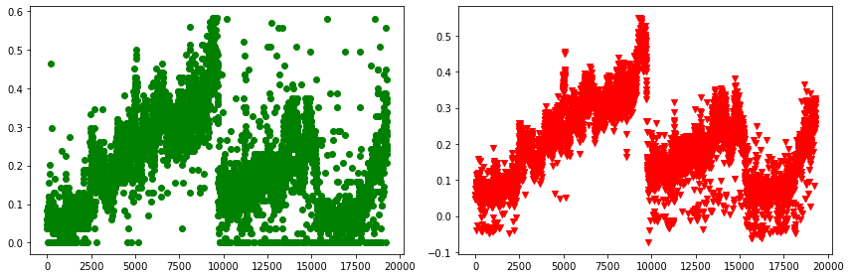

B.
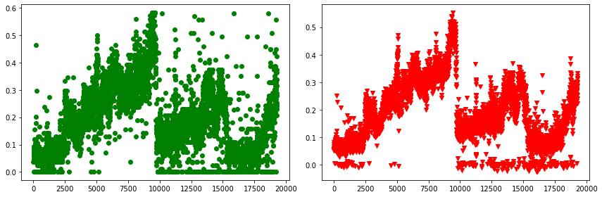

Figure. 4. A comparison between predicted and oridinal y_test (y-axis) vs. index (x-axis). Green represents the y_test and red represents y_pred_test. A- shows the model with fluorescence parameters. B. shows the models without.

